**Business Requirements Document (BRD)**

**Project Title:** Health Wellness Hub:  
**Date:** November 19, 2024

**1. Project Overview**

**Objective:**  
The Wellness Hub aims to provide a comprehensive platform for tracking and improving physical, mental, and emotional health. By simplifying the health management process, the system helps users who may struggle with maintaining a healthy lifestyle to take control of their health. The platform is designed to simplify health management by integrating multiple wellness aspects diet, exercise, and mental health into one seamless experience.

**2. Business Needs**

**Key Pain Points Addressed:**

* Challenges in monitoring and correlating diverse health and wellness metrics effectively.
* Fragmentation among systems for tracking diet, exercise, and mental health.
* Insufficient insights into long-term trends impacting overall well-being.

**Business Benefits:**

* Enhanced user engagement through tailored dashboards and actionable insights.
* A robust, scalable platform capable of supporting growing user and data demands.

**3. Stakeholders**

* **Primary Users:** Individuals looking to monitor and improve their overall well-being.
* **Admins:** Manage system configurations, reference data, and access reports for aggregated user insights.
* **Business Owners:** Ensure the platform aligns with market needs and delivers business value. (Future feature)

**4. Functional Requirements**

**4.1. Holistic Health Tracking**

* **Metrics Logging:** Users can record essential health metrics, such as height, weight, blood pressure, and heart rate.
* **Historical Data Analysis:** The application enables users to analyse trends through visualizations of historical data logs, offering insights into their overall health progress.

**4.2. Diet Management**

* **Meal Logging:** Users can log meals and snacks, capturing details like portion sizes.
* **Calorie and Nutrition Insights:** The application utilizes external APIs, such as the Nutritionix API, to provide real-time analysis of calorie intake and nutritional details.
* **External API:** We have used external API to get the nutrition analysis of a food intake by the user.

**Links:**

**4.3. Exercise Tracking**

* **Activity Logging:** Users can log exercise sessions, specifying details such as activity type and activity duration.
* **Calorie Burn Estimation:** The application estimates calories burned during activities using APIs like Nutritionix.
* **External API:** We have used external API to get the calories burned details based on the exercises done by the user.

**Link:**

**4.4. Mental Health Support**

* **Mood and Stress Tracking:** Users can log mood and mental health metrics, including reasons for stress and journal entries for reflective insights.
* **Relaxation Techniques:** The application offers stress management solutions through techniques and exercises recommended via external APIs like GEMINI, tailored to the user’s stressors.

**4.5. User Dashboards**

* **Personalized Health Dashboards**: Users have access to interactive dashboards summarizing health metrics, nutritional details, exercise sessions and stress maintaining.

**4.6. Reporting and Admin Capabilities**

* **Admin Dashboards:** Admins can monitor aggregated health data and maintaining user profiles.
* **Reference Data Management:** Admins can manage reference data such as predefined health metrics, exercise types, and mood categories.

**5. Non-Functional Requirements**

* **Performance:** The system should handle more number of users without performance degradation.
* **Scalability:** Ensure the architecture supports future feature expansion and increased user base.
* **Security:** Implement JWT-based authentication for secure access to data.
* **Availability:** Ensure 99.9% uptime for the platform.
* **User Experience:** Provide a responsive, intuitive, and accessible user interface.

**6. Technical Requirements**

**Technology Stack:**

* **Backend:** .NET Core, Entity Framework Core
* **Frontend:** Angular with Toastr notifications
* **Database:** SQL Server
* **Deployment:** Azure with Docker containers for microservices
* **APIs:**
  + Nutritionix API for dietary insights

**7. Database Design**

**Key Tables:**

* **User:** Stores authentication details and links to user profiles.
* **Metrics:** Definitions of health metrics.
* **MetricsType:** Logs individual metric records.
* **ExerciseType:** Types of exercises defined by the admin.
* **ExerciseLog:** Records user exercise sessions.
* **Mood:** Definitions of moods tracked in mental health logs.
* **MentalHealthLog:** Logs mood types.
* **Diet:** Tracks meal logs and nutritional data.

**8. Block Diagram**

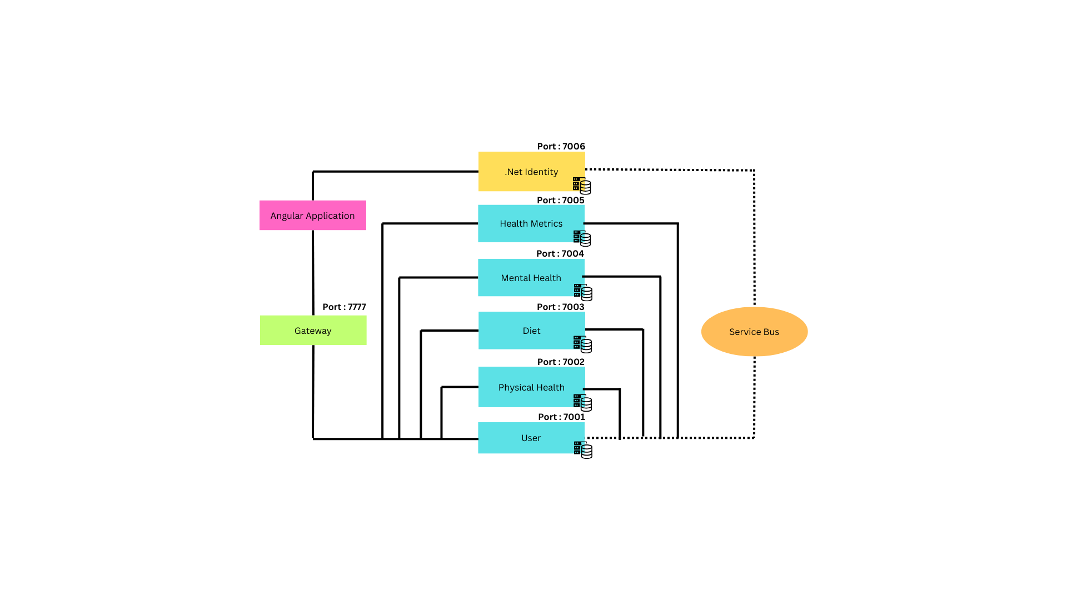

**9. Flow Chart**

